5CS032 Computer Networking

Workshop – Week 1

STUDENT NAME:
STUDENT NUMBER:
Answer the questions below, and follow the procedure using the equipment in the network racks. You must demonstrate your work to the workshop tutor as part of your marks comes from this.
Room MI205
The machines in MI205 are configured differently than in the other university labs.

To logon
Username = stech_user
Password = mi205user1
To use the internet you will be asked for your normal university login credentials.

Workshop 1 – Part 1
Objectives:
- Understand what the ping command is
- Utilize the ping and extended ping command

The ping command is used as a basic tool in network troubleshooting, and is used from a command window. To access the command window use the menu options START > ACCESSORIES > COMMAND PROMPT
1. Use the internet and the command window to answer the following questions
What is the basic ping command used for?
____________________________________________________________________________________________________________________________________________________________________________________________________________________________________________________________________________________

What does the command ping localhost do? Are there any variations on the localhost option that perform the same task? What are they?
____________________________________________________________________________________________________________________________________________________________________________________________________________________________________________________________________________________

What do the parameters reported back by ping of time and TTL represent?
____________________________________________________________________________________________________________________________________________________________________________________________________________________________________________________________________________________

Ping your favourite website and list its response times.
____________________________________________________________________________________________________________________________________________________________________________________________________________________________________________________________________________________

What is its IP address
_____________________________________________________________________

How do you stop a ping command if it is failing?
_____________________________________________________________________

Ping the websites WWW.BBC.CO.UK and WWW.WIKIPEDIA.COM and note down the response times and TTL values. Is there a difference between the 2 sets of values and why?
____________________________________________________________________________________________________________________________________________________________________________________________________________________________________________________________________________________________________________________________________________________________________________________________________________________________________________________________________________________________________________

What is the Ping command to send 9 packets as a test?

--------------------------------------------------------------------------------------------------------------------------------------

If the ping test returns the following messages what do they mean?
Destination Host Unreachable
------------------------------------------------------------------------------------------------------------------------------------------------------------------------------------------------------------------------------------------------------------------------------------------------------------------------------------------------------------------------------------------------------------------------------------------------------------------
Request Timed out
---------------------------------------------------------------------------------------------------------------------------------------------------------------------------------------------------------------------------------------------------------------------------------------------------------------------------------------------------------------------------------------------------------------------

Traceroute is another tool used for network and internet diagnostics. Search the internet to determine what it does and describe what it can be used for.
____________________________________________________________________________________________________________________________________________________________________________________________________________________________________________________________________________________

To undertake networking workshops, you need to have administrative rights on the machine. This is done by running a virtual copy of Windows 7 using VMWare. Do this by following the procedure below.

Booting the Workstation

- Click on the VMware player icon, and select the ‘Networking Windows 7” VM available on the left hand panel, and click play this machine.
- You should now have a VMWare copy of Windows 7 which gives you administrative rights and connection to a rack cabinet..
- Maximize the desktop window (if not already maximized).
- On the top bar of the VM select Player> manage> Virtual Machine Settings
Set the network adapter settings as shown in the image below
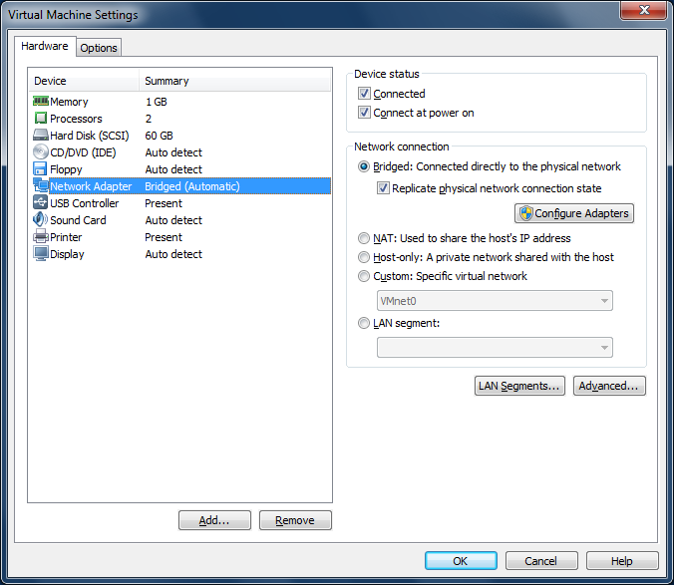

Workshop 1 – Part 2
Objectives:
- Connect a simple LAN using an Ethernet switch
- Configure IP addresses on workstations
- Test the LAN for connectivity

Logical Diagram of LAN
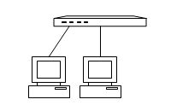
Logical diagram for network
Working in pairs. Connect the workstations to the switch using straight-thru cables.

A. What physical topology is used for this LAN?

B. What networking media is used?

Open up the virtual terminal and using the procedure below; configure the IP address and subnet mask on each workstation:

Procedure for Configuring the IP Address on Windows 7

- On the desktop select the network connections icon and a new panel opens up.
- Select the Network And Sharing Centre > Change Adapter settings
- right-click the local network connection and select Properties
- Select Internet Protocol version 4 (TCP/IP) and click the Properties button
- Select Use the following IP address and enter the IP address and Subnet mask (all other fields should be left blank). Your IP address should be set to 192.168.1.XX
  - where XX is the last 2 digits of your desk number + 100,
  - the subnet mask is 255.255.255.0.
- Click Okay and then close on these dialogue boxes.

Using the network address 192.168.1.0 / 24, write down the host IP address for each workstation:
Your Workstation : ______________________
Colleagues Workstation : ______________________

Write down the subnet mask for this network:
Subnet mask: _______________________

What protocol is being used on this network? _______________________________
Test the connectivity of the LAN using Ping:
- Open a command window
- Confirm that TCP/IP is set up on your machine by entering in the Command Prompt:
ping 127.0.0.1

What alternative could you use?
______________________________

- Confirm that you have set the correct IP address by entering the command:
ipconfig
- Test that you have connectivity to each of the other hosts on the LAN by pinging each of their IP addresses in turn.
A. What is the address 127.0.0.1 called? ______________________
B. What does the command ipconfig do?

_____________________________________________________________________________________________________________________________________________________________________________________________________________________________________________________
Workshop 1 – Part 3
Objectives:
- Create a peer to peer network
- Demonstrate it works through a file share
Using the configuration and settings you have applied from part 2, your task is to create a share on a folder on your workstation this will allow others to access your files. To demonstrate file sharing you will create a file and allow your partner to access it, who will make some changes to it and save the changed version. You will then demonstrate this changed version to your tutor. The procedure is as follows
- Open up the control panel > network and sharing centre
- Select change advanced sharing settings and expand home or Work profile.
- Make sure file and printer sharing is turned on.
- Turn off ‘password protected sharing’ .
- Save changes and close dialogue windows.
- Use windows explorer to make a folder in the documents folder and create a simple text file using notepad in that folder, add some simple text to it, save close the file.
- Right click on the new folder and select properties
- Click sharing tab then ‘advanced sharing’ button
- Check the ‘share this folder’ box
- And then click permissions, click add
- Type in guests in the box titled “enter the object names too select”, then ok
- Then for guests check the full control option in the permissions box, click ok and then ok again.
- Select the security tab, and then edit, add, type in guests in the box titled “enter the object names too select”, ok this.
- Then for guests check the full control option in the permissions box, click ok and then close.
We now have shared our files in that folder. To test you need to open up your partners text file and edit the message they have written in it, and save the file. You will need to demonstrate this has worked to your tutor by opening up your own text file to illustrate that the file has been changed by your partner. The procedure to open the file is:
- In windows explorer in the address line type \\192.168.1.XX\partenersfoldername where XX is the ip address of your partner’s workstation.
- Open up their file, edit and save it.
- Now open up your own file and demonstrate to your tutor that it has been edited.

